Pokhara University

Level: Bachelor | Semester – Fall | Year : 2011
Programme: BE |  | Full Marks: 100
Course: Mathematical Foundation of Computer Science |  | Pass Marks: 45
 |  | Time : 3hrs.

Candidates are required to give their answers in their own words as far as practicable.
The figures in the margin indicate full marks.

Attempt all the questions.

 | - How many paths of length 4 are there from first node to third node in the simple graph represented by the following adjacency matrix? Also, investigate the paths.  G = 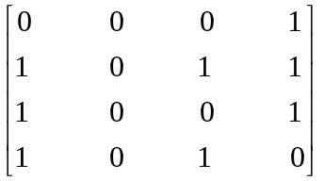  - Show that K₅ is nonplannar graph.  - Show that in an undirected graph, there are even number of vertices of odd degree. | 5  5  5
 | - When does the complete bipartite graph K _{m,n} conttain an Euler cycle? Give a suitable example.  - Apply Dijkstra's shortest path algorithm to find a shortest path and length of the shortest path between vertices a and e in the graph given below:  2  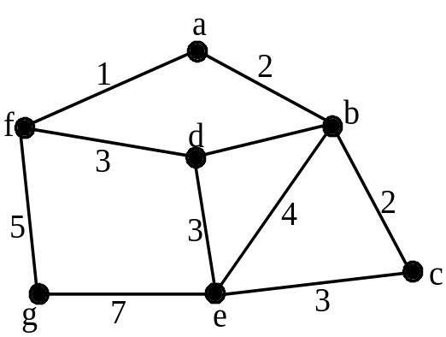 | 7  8
 | - Use Mathematical Induction to prove that:  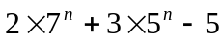 is a multiple of 24.  - Solve the following recurrence relation for the initial conditions given: | 8  7
 | - Suppose that the Postal Department prints only 5 and 9 cent stamps. Prove by using Mathematical induction that it is possible to make up any postage of n-cents using only 5 and 9 cent stamps for n > 35.  - Determine the truth value of the statement  For some x, for some y if x+5<y-3, then x² + 25< y² - 9. | 7  8
 | - Verify the validity of the following argument by using rules of Inferences:  If Sanjay does not work in a bank, then he is not a bank manager.  Sanjay does not use Tally.  If Sanjay works in a bank, then he uses GNUCash.  Either Sanjay is a bank manager or he uses Tally.  Hence, Sanjay uses GNUCash.  - Give an argument using the rules of inference to determine whether the conclusion follows from the given hypothesis or not. To win a gold medal, the athlete must be very fit. If he does not win the gold medal, then either he arrives late for the game or his training was interrupted. If he is not fit for the game, he will blame his coach. If he blames his coach or his training is interrupted, then he will not get into the final. Therefore if he gets into the final, he will not have arrived late. | 8  7
 | - Assume that deer population of Rustic Country is 500 at time n = 0 and 550 at time n = 1 and that the increase from time n – 1 to time n is twice the population increase from time n – 2 to time n – 1. Write a recurrence relation and an initial condition that define the deer population at time n and then solve the recurrence relation.  - Write a grammar that generates the strings, in which strings over {a, b} not ending with aabb. | 7  8
 | Write short notes on any two:  - Rules of inference for quantified statements  - Context-Sensitive grammar  - Universal quantification | 2×5

